**ONLINE CAMPUS SELECTION SYSTEM**

**A Mini Project [ASP.NET / C# / MS SQL]**

**Submitted By :**

**Akash S**

**Gobalakrishnasridhar T**

**Hariharan T**

**Kuttralanathan K**

**Rajagurunathan M**



September - 2020

**PROJECT DESCRIPTION**

**Project Title :** Online Campus Selection System

**Abstract :** The system developed for job seekers and recruiters. The system provides an intermediate place for job seekers and companies.

**Type of Project :** Web Application

**Technology :** ASP.Net - C# Language

**Database :** SQL-Server

**WebApplication Name**:



**DESCRIPTION:**

The Online Campus Selection System developed for the HR Department includes automating the functioning of the HR Department. This system is helpful for the HR Department to make an easy student selection process. We can say this system is similar to the Human Resource Management System.

The online campus selection software works at college or university. The College invited a recruiter/company to register in this system and help to get employees easily as per their qualification and requirements. Other hand, college has all the student data submitted in this system so students can get a job easily. The system is a mutual place for students and company. The online campus selection system helps students to get jobs and companies to get employees.

**OBJECTIVE :**

Development of a rich web based Campus Selection System for Universities and any Companies. Online Campus Selection System is developed for smooth working of Human Resource Departments. Universities and companies can get benefited through this system. This Software is fully integrated with Student and Company Relationship Management and developed in a manner that is easily manageable, time and cost saving that shows relieving one from manual work. Online Campus Selection provides automated technical screening, This feature helps in many ways like saving cost, time and paperwork, this shows the paperless environment, unlimited Custom and reports.

**PROJECT DEMO:**

**Type of Users:**

1. Student/Job Seeker
2. Company/Recruiter

**Project Flow:**

* **Student Functionalities:**

1. Create Account : Enter Personal Details

Enter Education Details

1. Login : Authentication
2. Student Dashboard (Home) : Students can view matched Jobs based on Skill and Qualification and Apply.
3. Applied Jobs : Student can view applied jobs
4. Student Inbox : Student can view job application status and details
5. Edit Profile : Student can edit personal , education details and can change passwords
6. Logout : Logout from the application

* **Company Functionalities:**

1. Create Account : Enter Company details
2. Login : Authenticate
3. Posted Jobs(Home) : Company can view posted jobs and its application count
4. Add Jobs : Company can add jobs in the application
5. Company Inbox : Company can view job application and can send response to that
6. Edit Profile : Student can edit personal , education details and can change passwords

.

1. Logout : Logout from the application

**DATABASE DESIGN**

**Entity Relationship :**

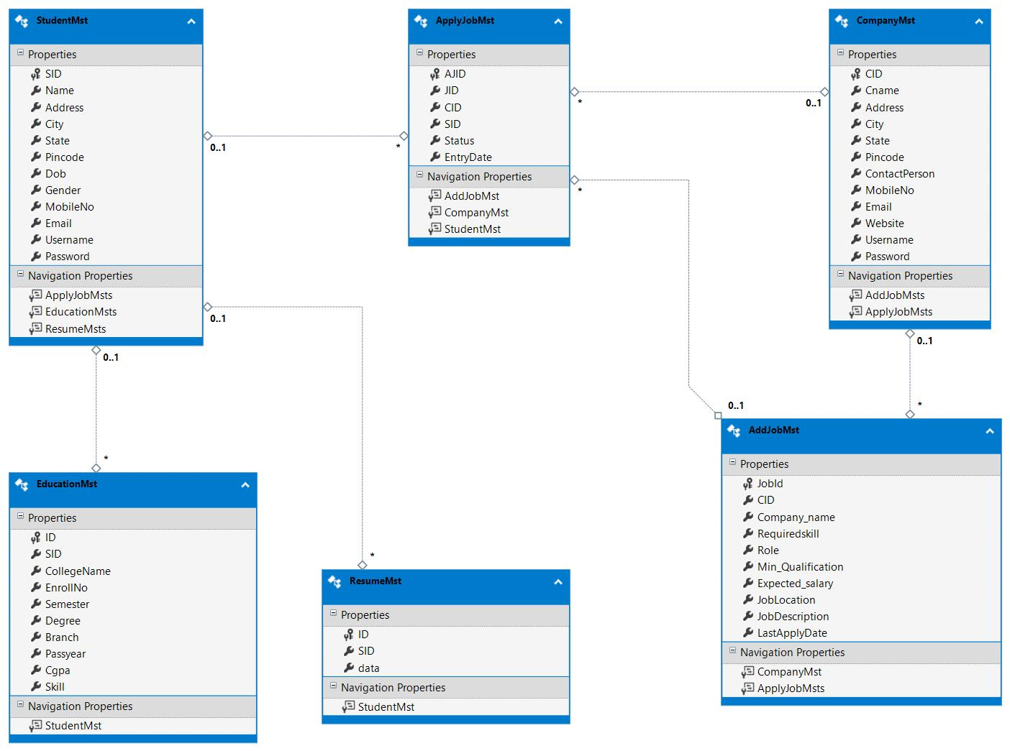

**TABLE 1: StudentMst**

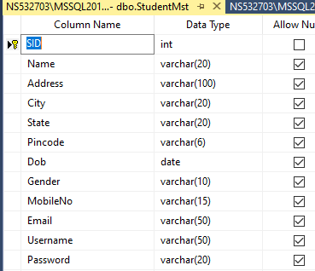

**TABLE 2: CompanyMst**

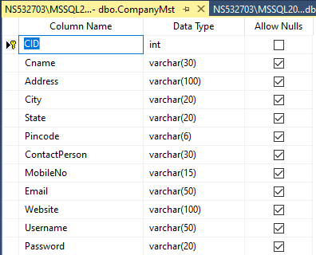

**TABLE3: AddJobMst**

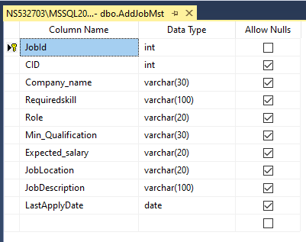

**TABLE4: AppliedJobMst**

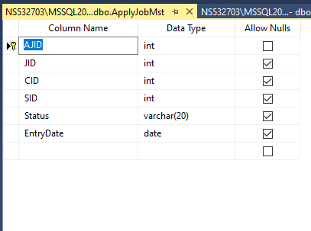

**TABLE5: EducationMst**

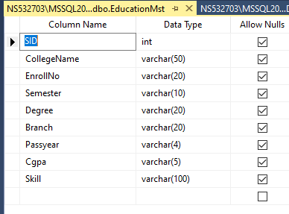

**TABLE6: ResumeMst**

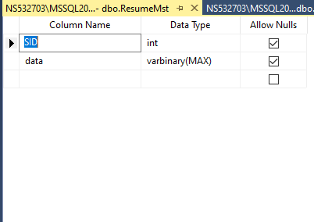

**SOURCE CODE**

**Login:**

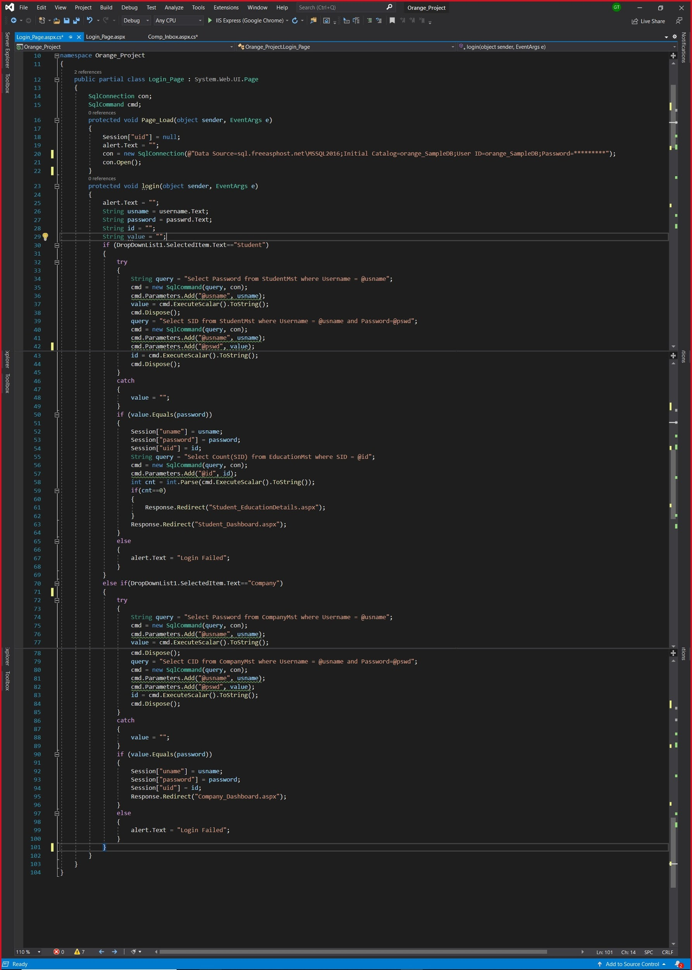

**Student Dashboard:**

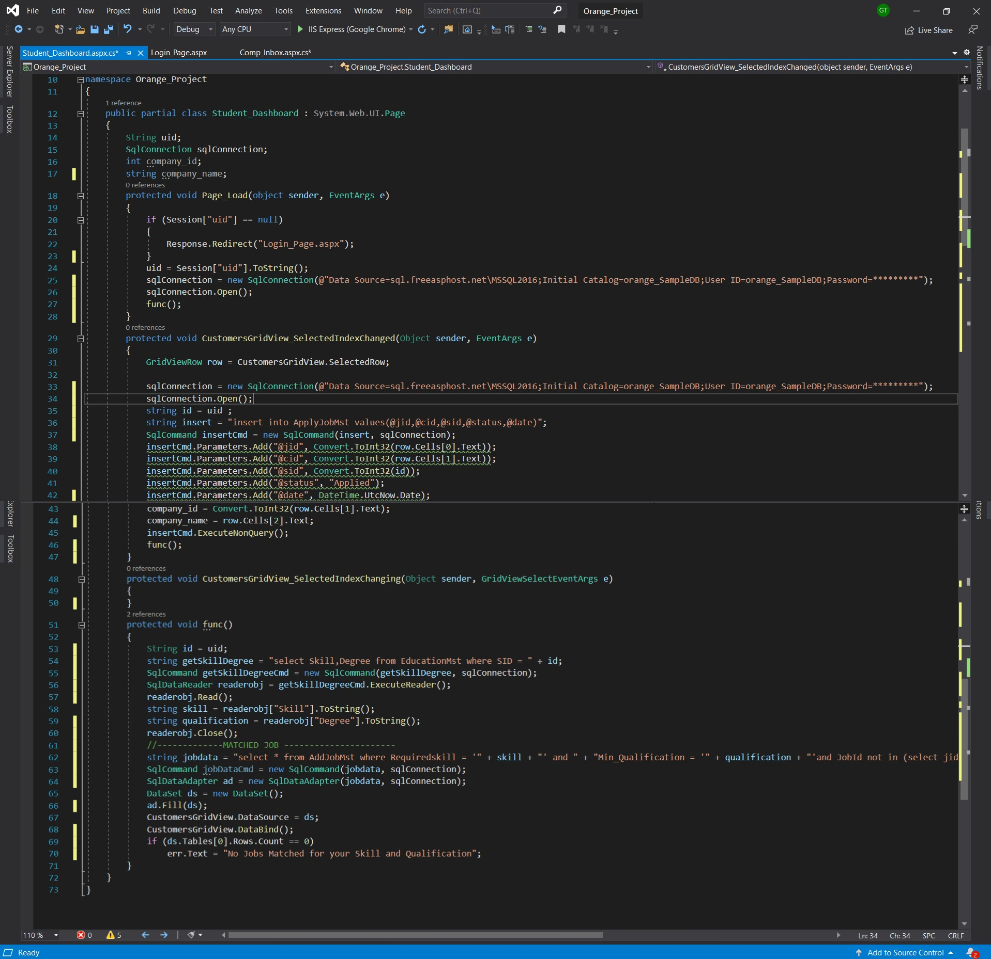

**Student Inbox:**

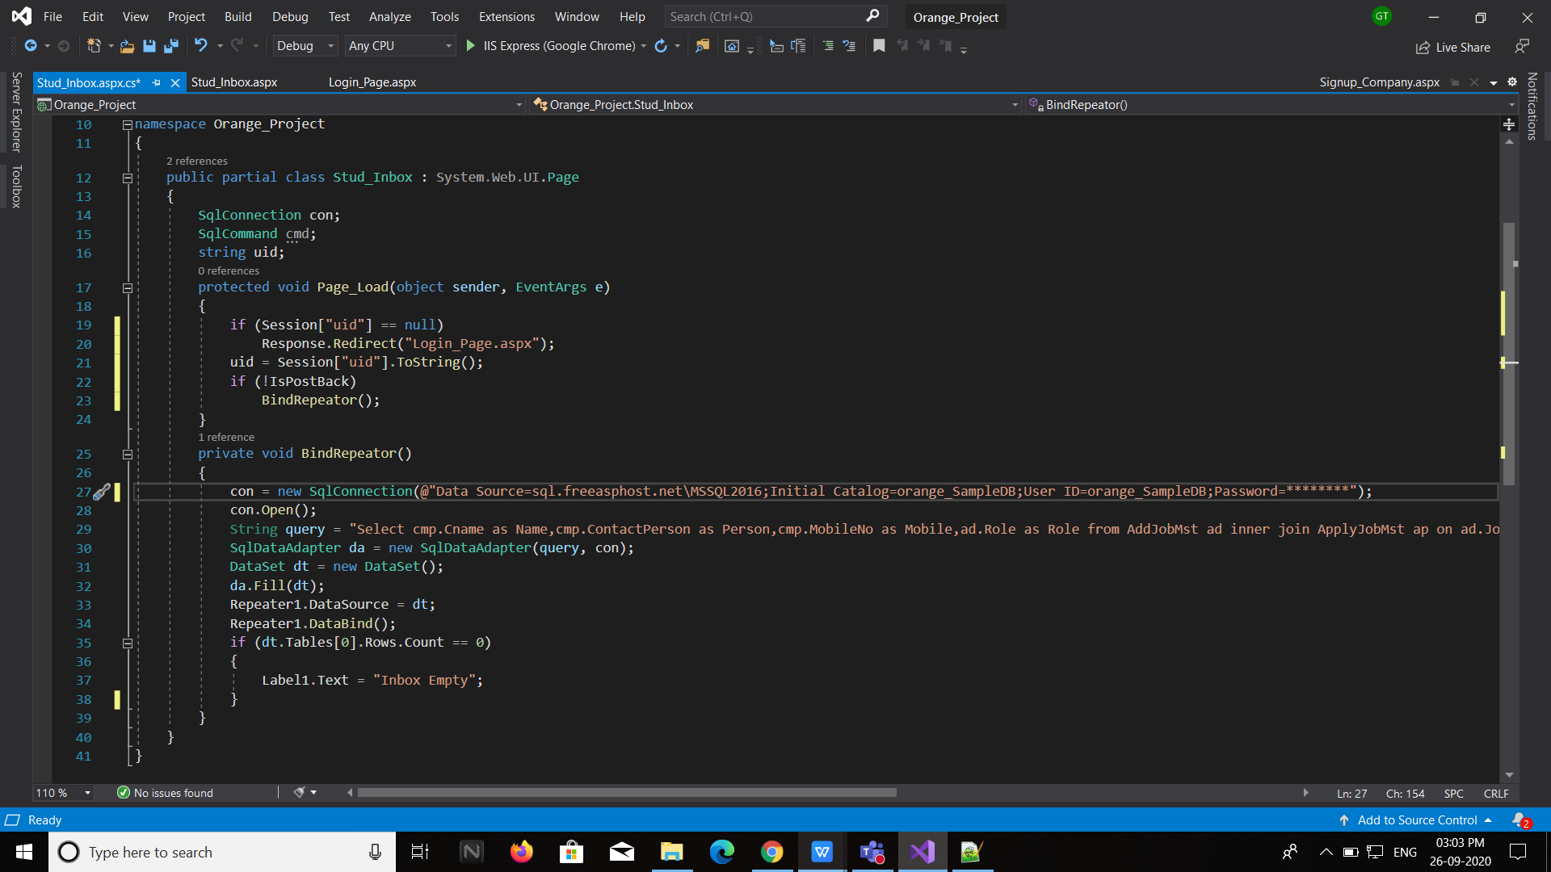

**Company Dashboard**

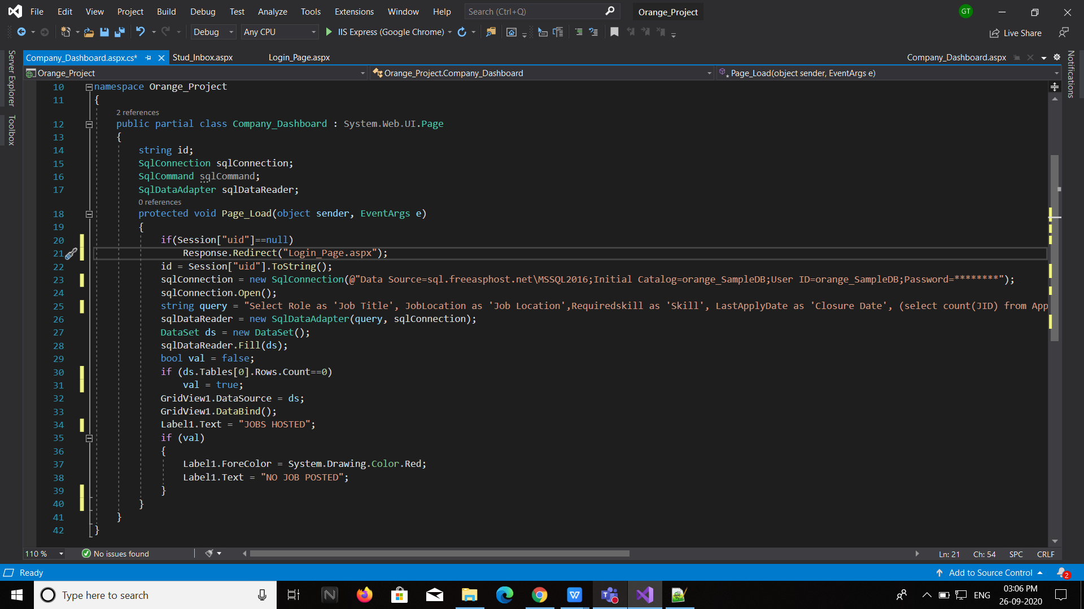

**Company Inbox**

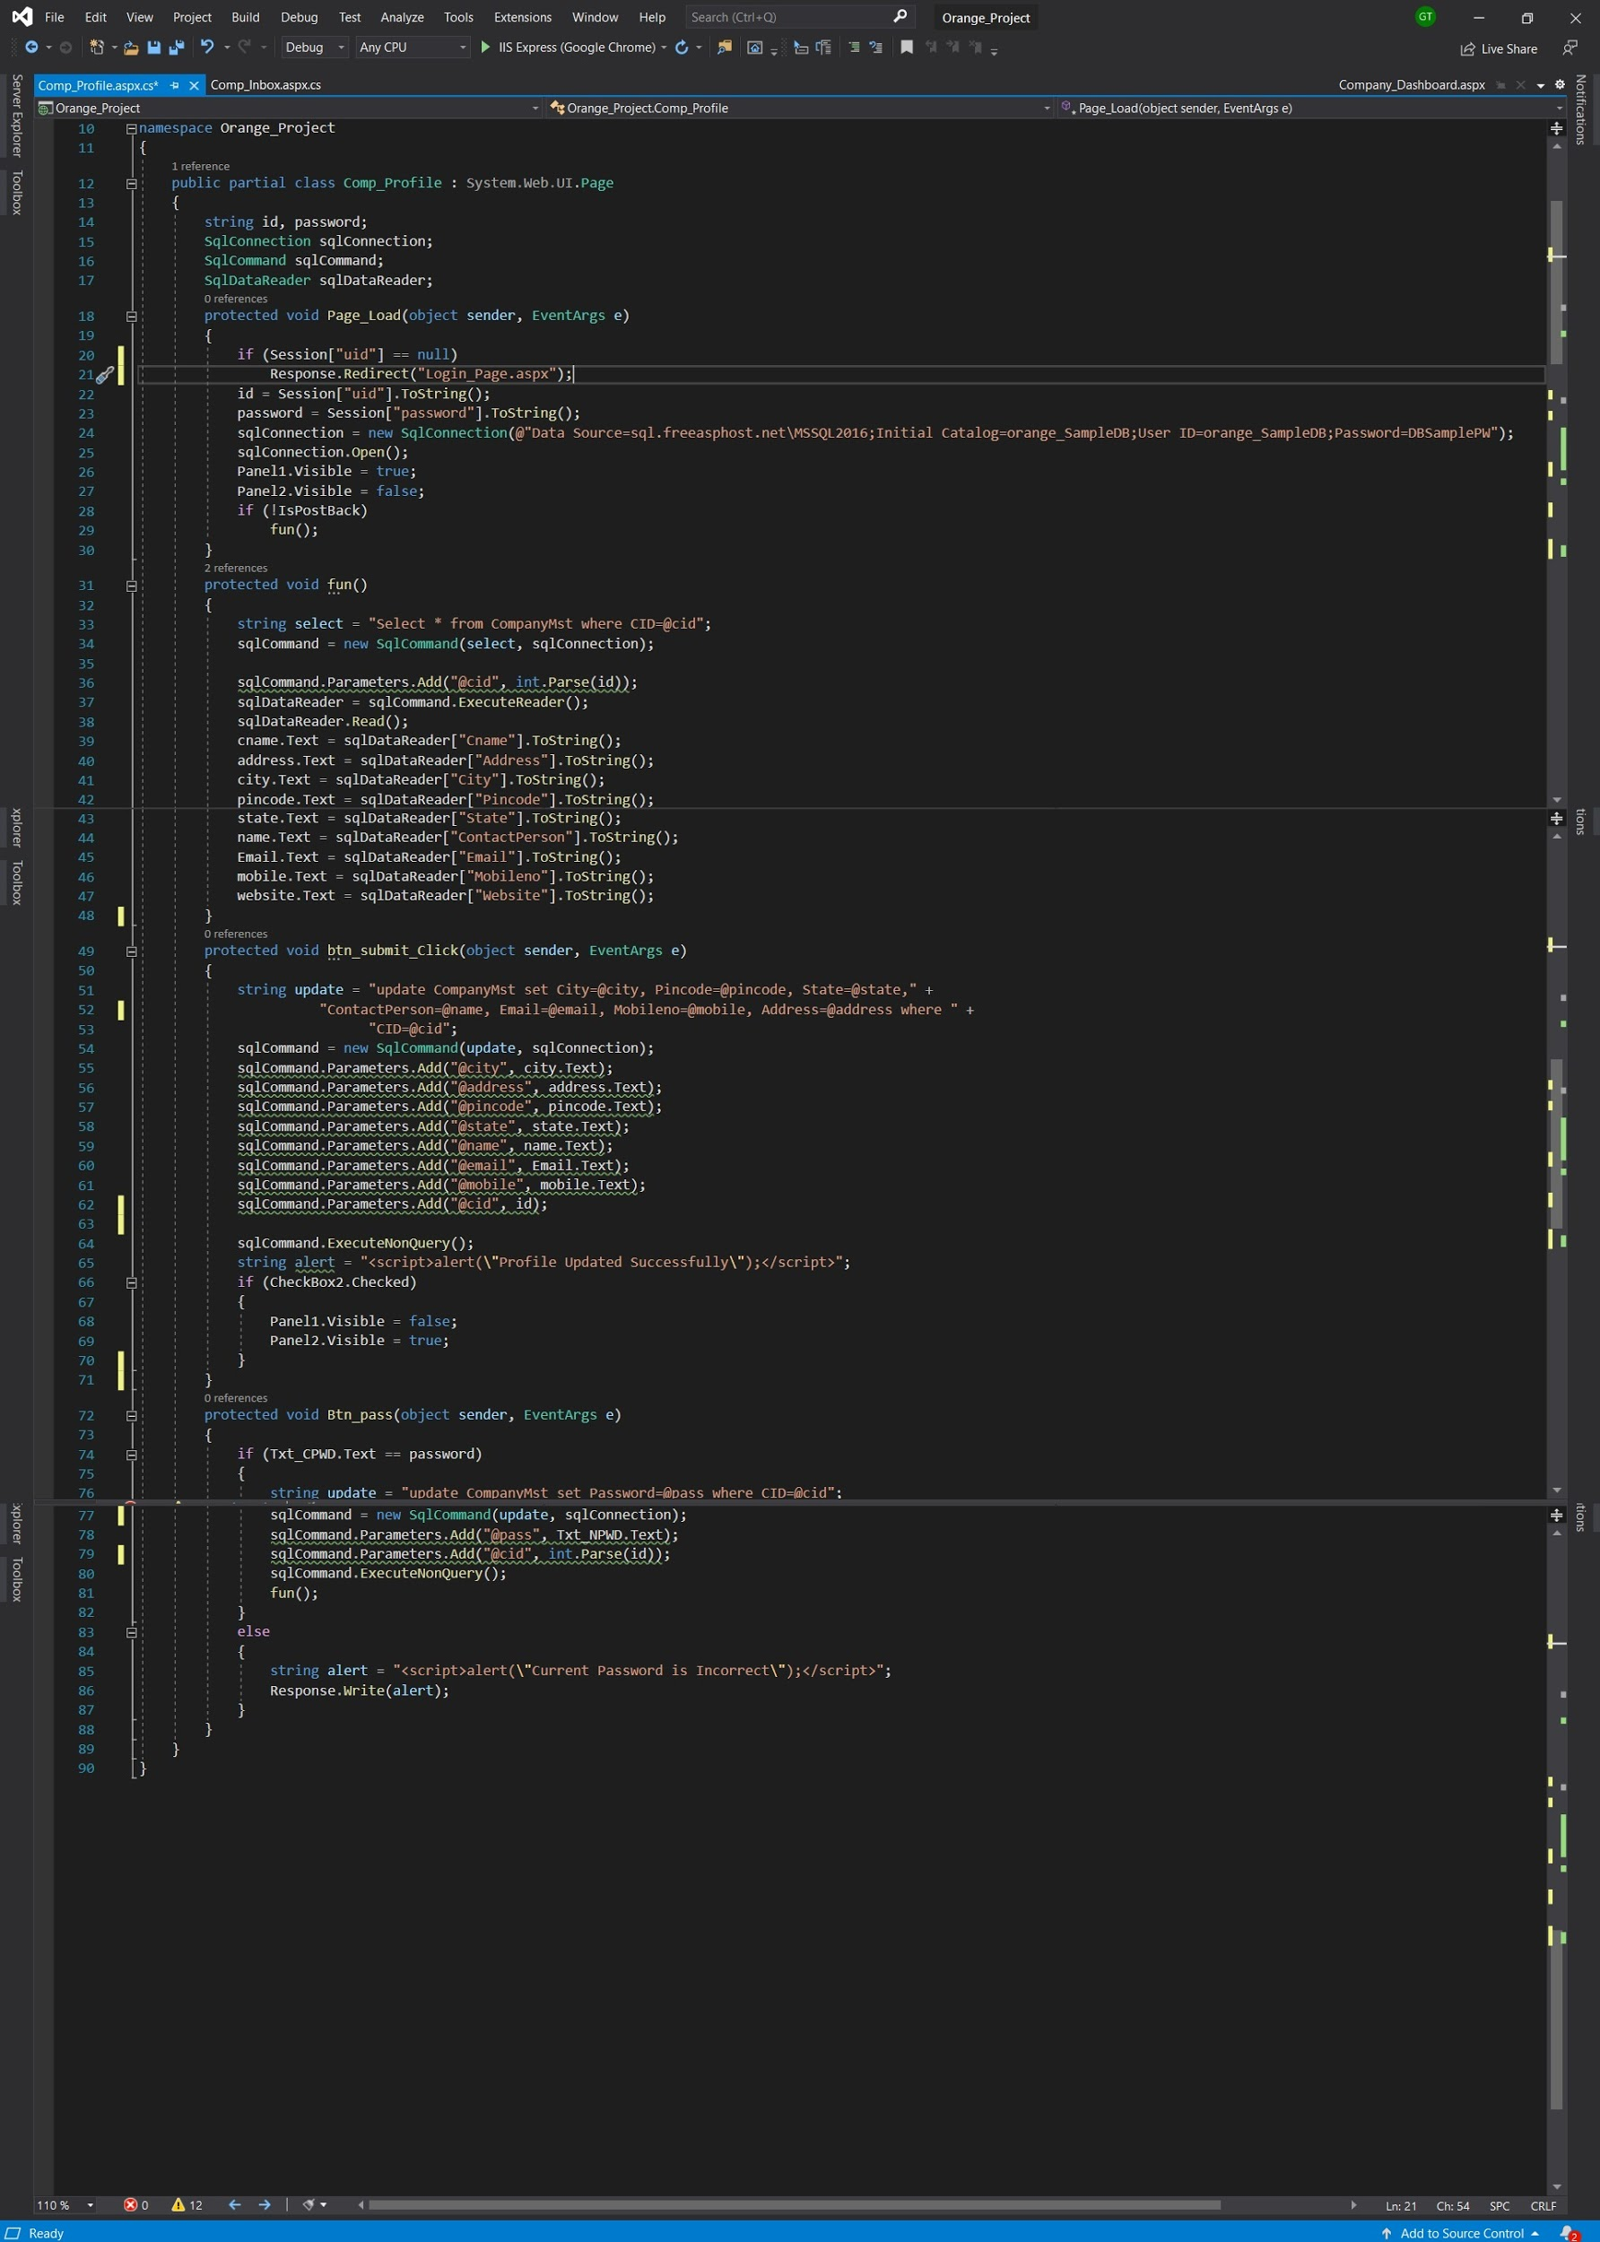

**PROJECT OUTPUT SCREENSHOTS**

**SCREENSHOT 1:** Login Page

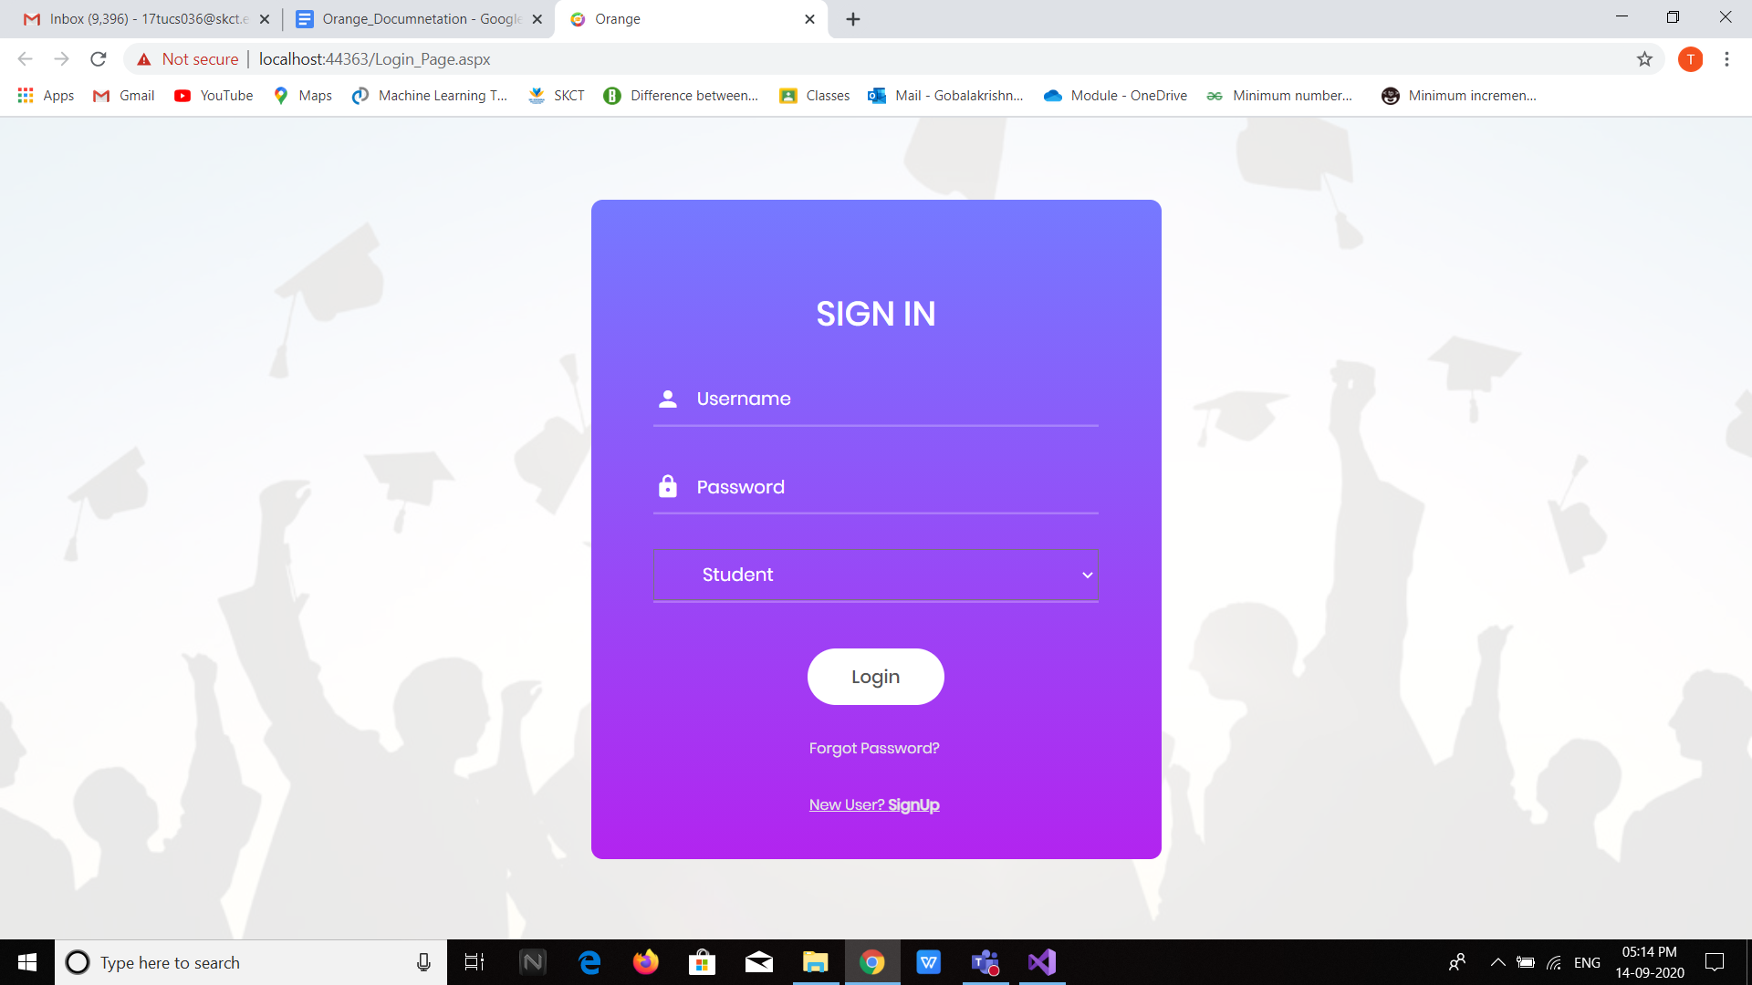

**SCREENSHOT 2:** Common Signup

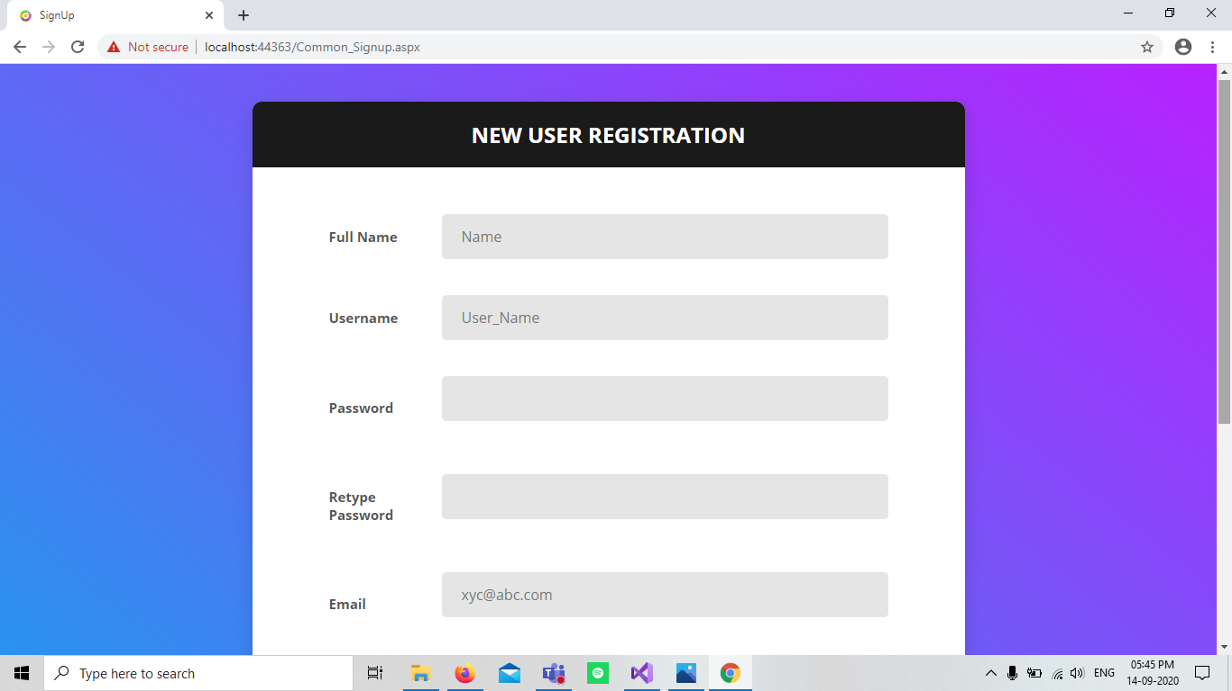

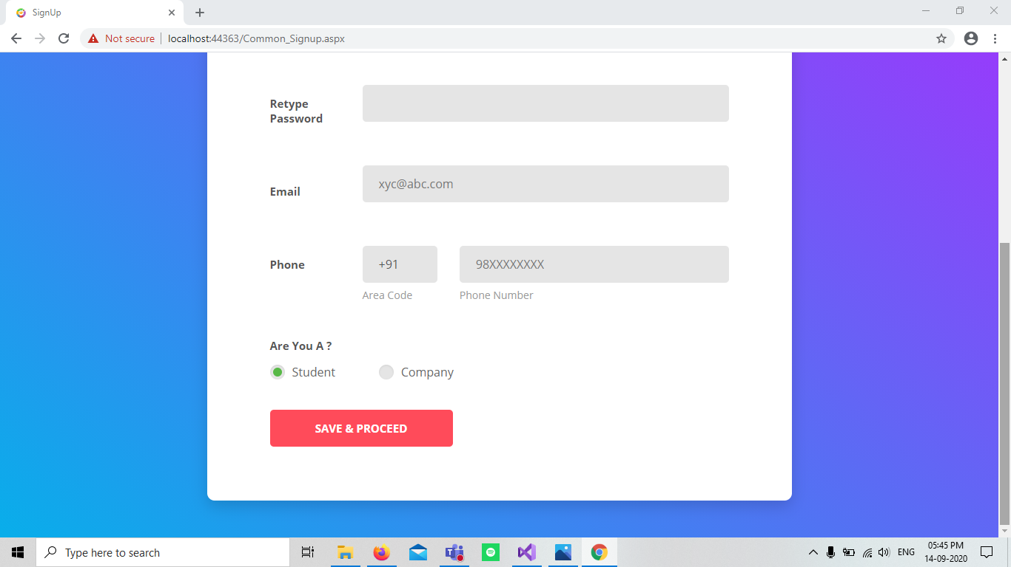

**SCREENSHOT 2.1:** Student Signup

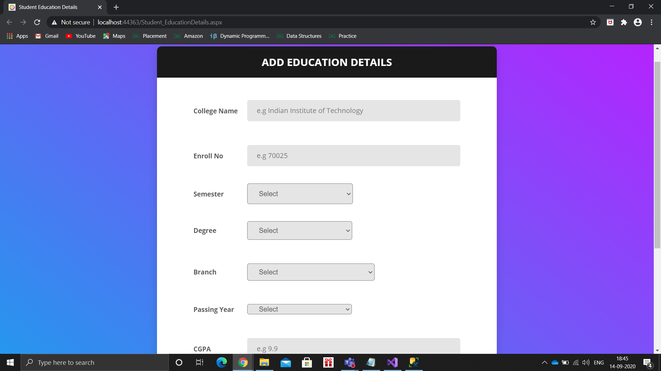

**SCREENSHOT 2.2:** Company Signup

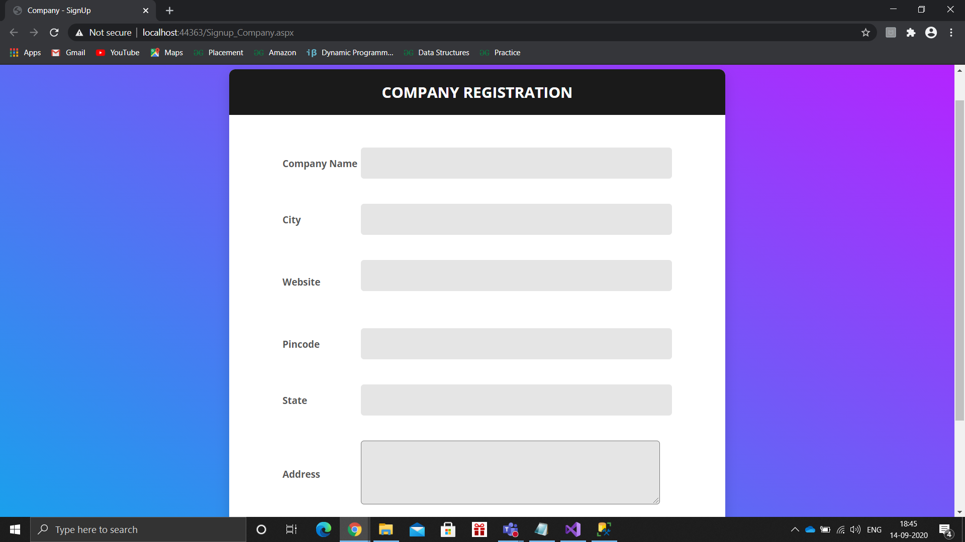

**SCREENSHOT 3:** Student Dashboard

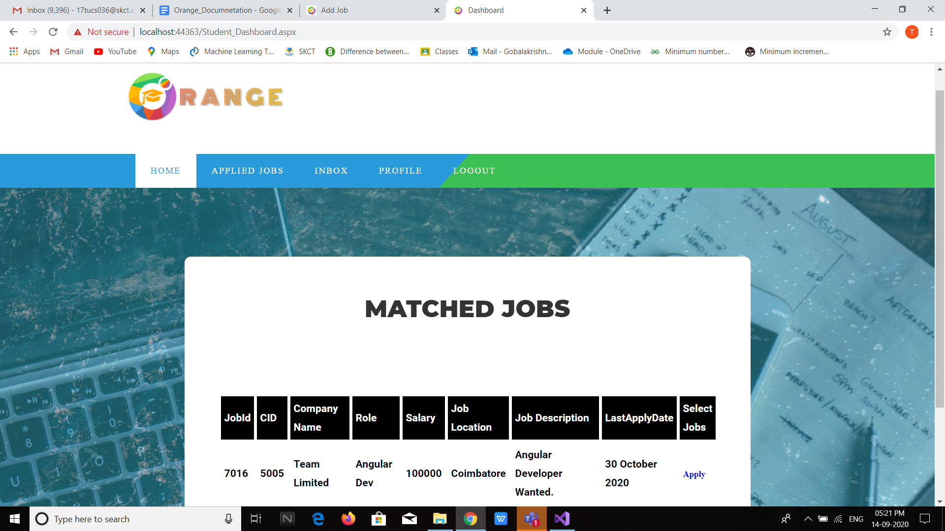

**SCREENSHOT 4:** Student - Applied Jobs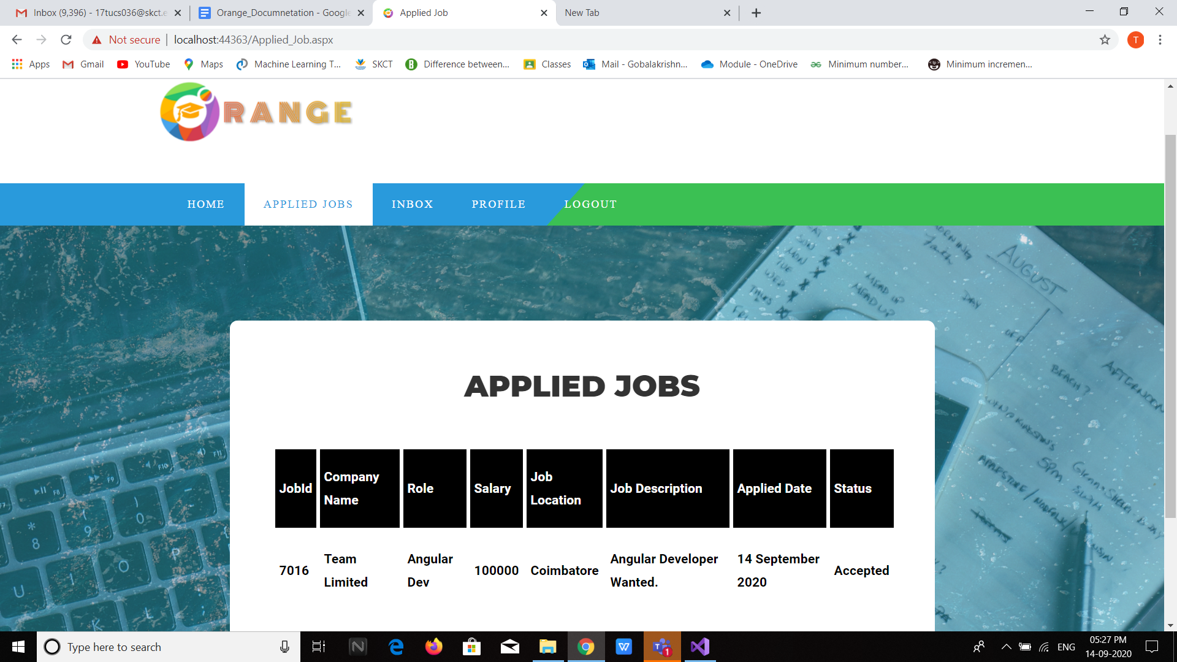

**SCREENSHOT 5:** Student - Inbox

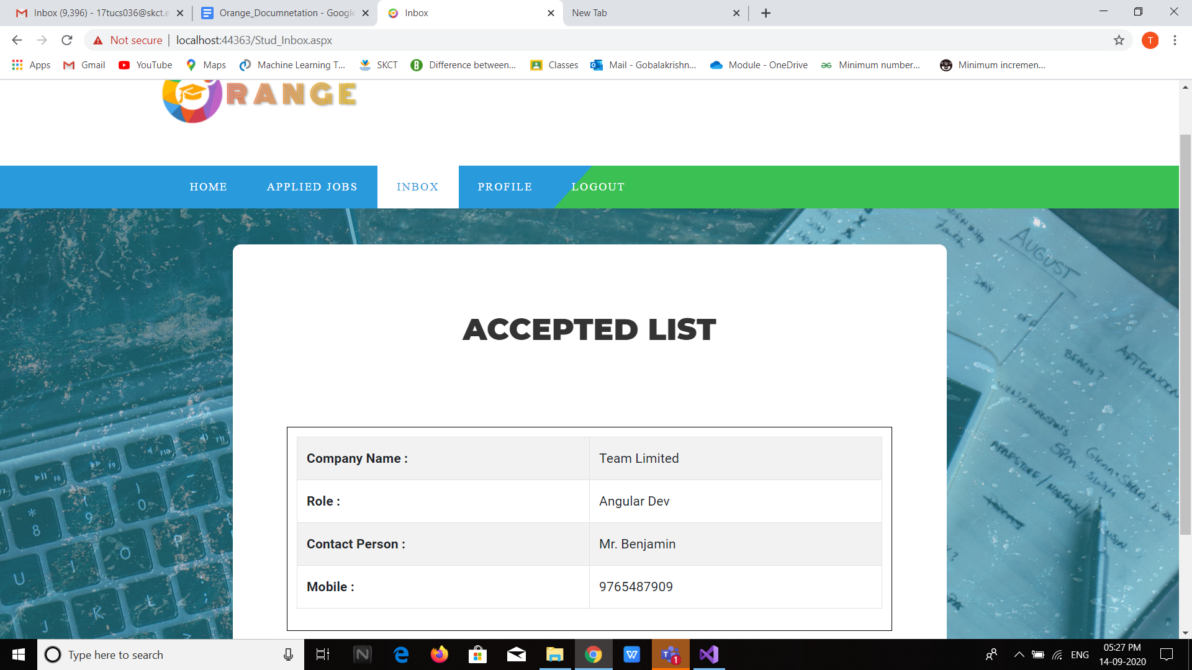

**SCREENSHOT 6.1:** Student - Edit Profile

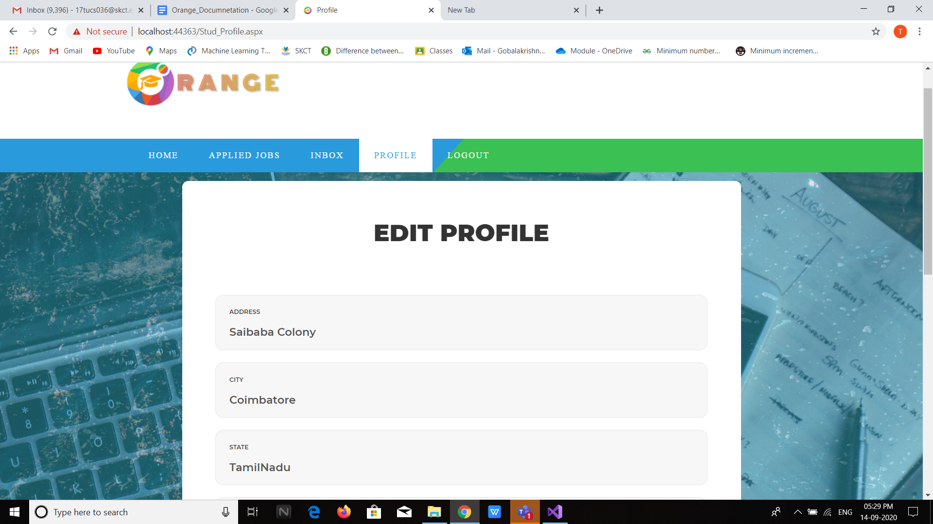

**SCREENSHOT 6.2:** Student - Update Profile

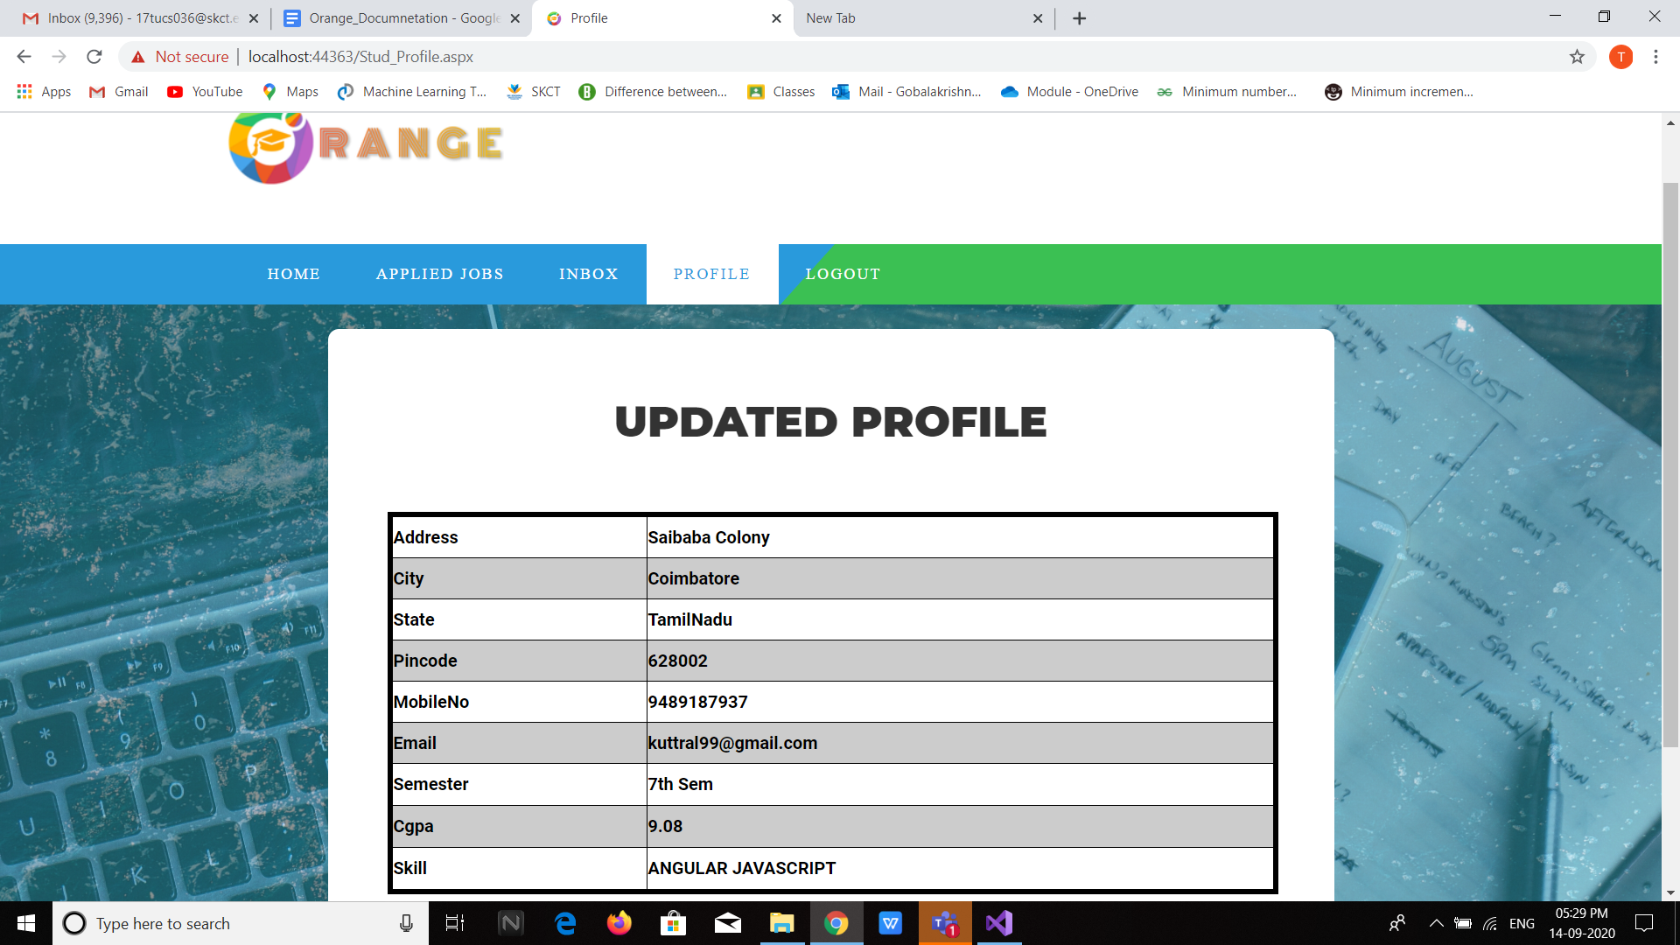

**SCREENSHOT 7:** Company Dashboard

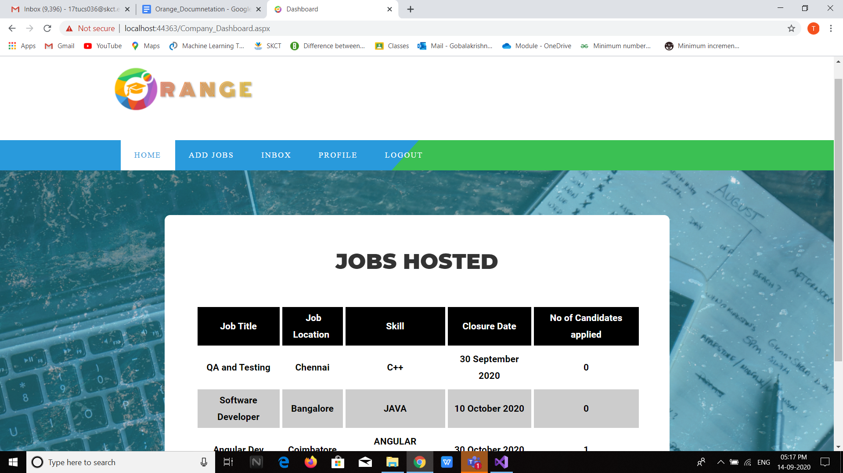

**SCREENSHOT 8:** Company - Add Job

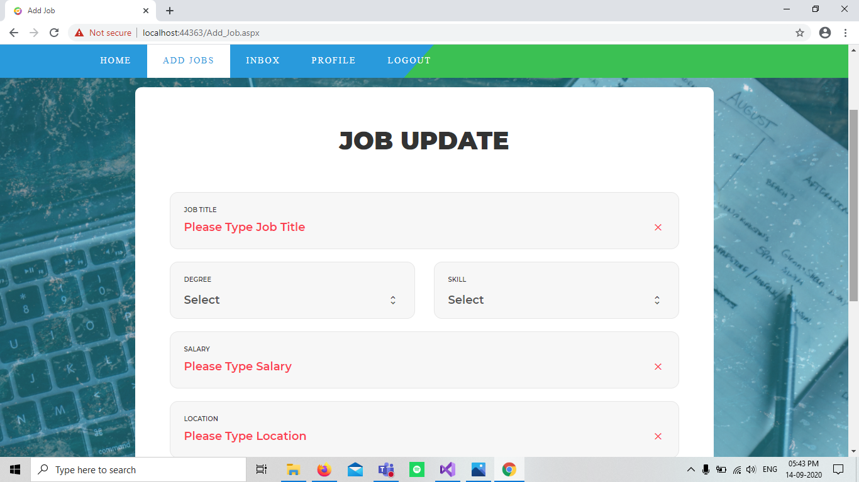

**SCREENSHOT 9:** Company - Inbox

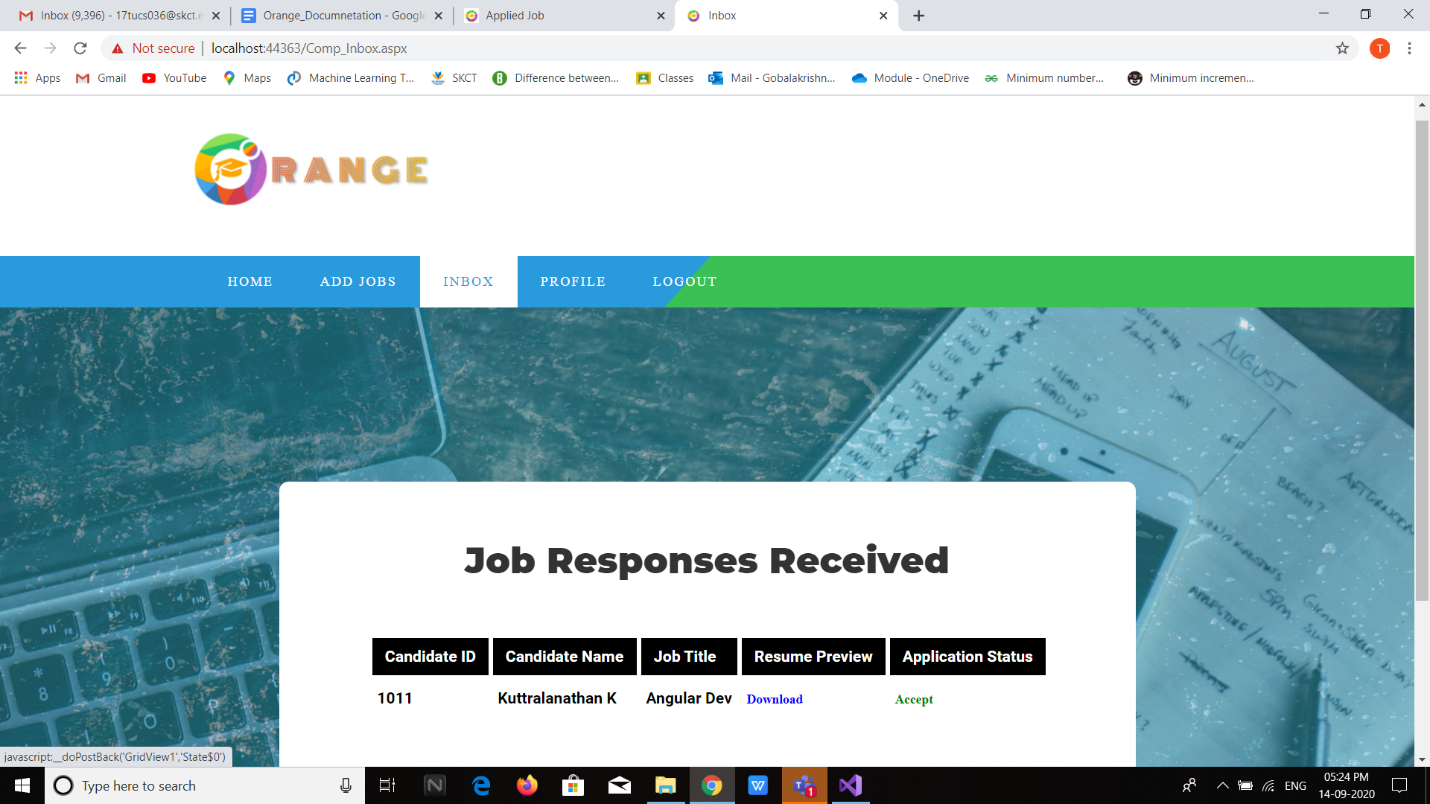

**SCREENSHOT 10.1:** Company - Edit Profile

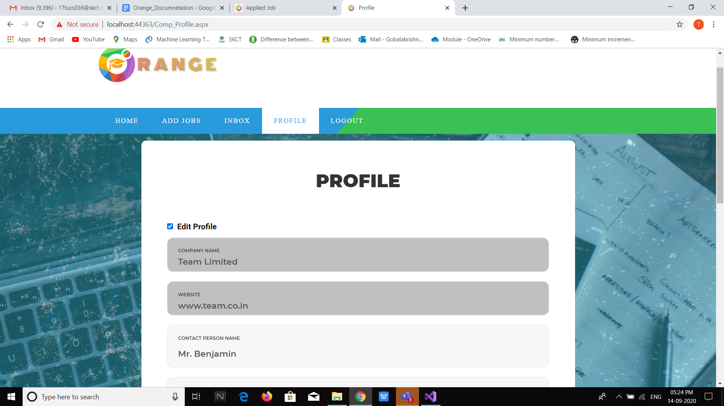

**SCREENSHOT 10.2:** Company - Change Password

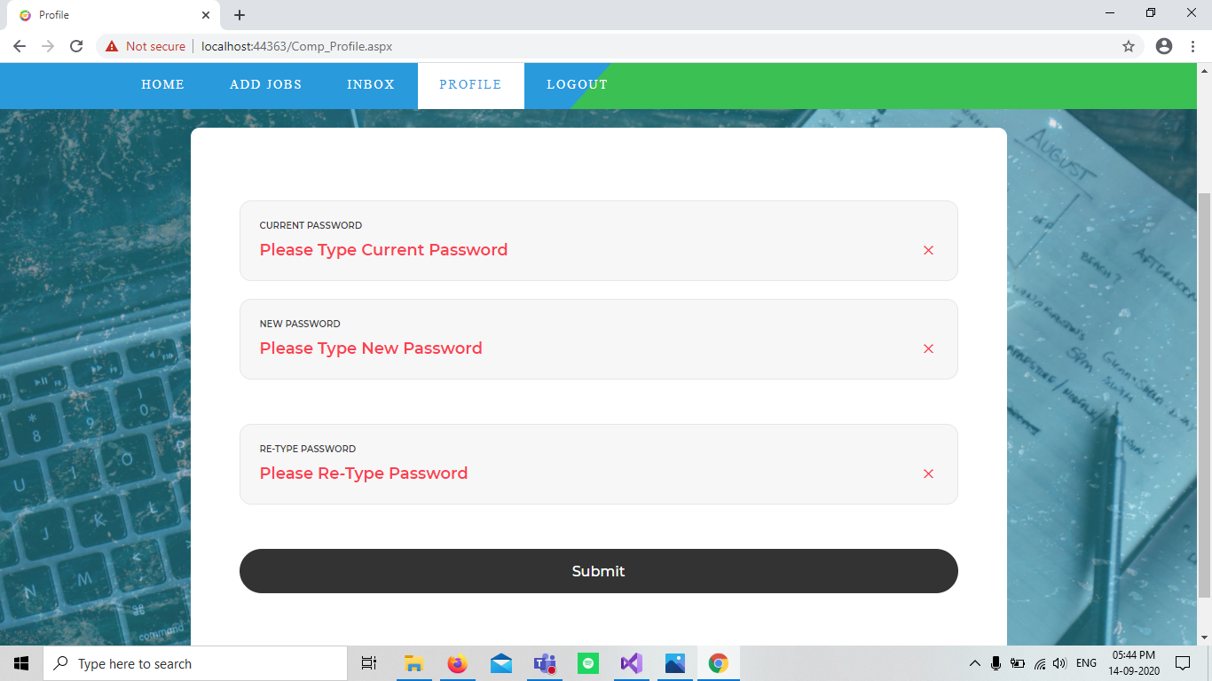

**SCREENSHOT 11:** Forgot Password

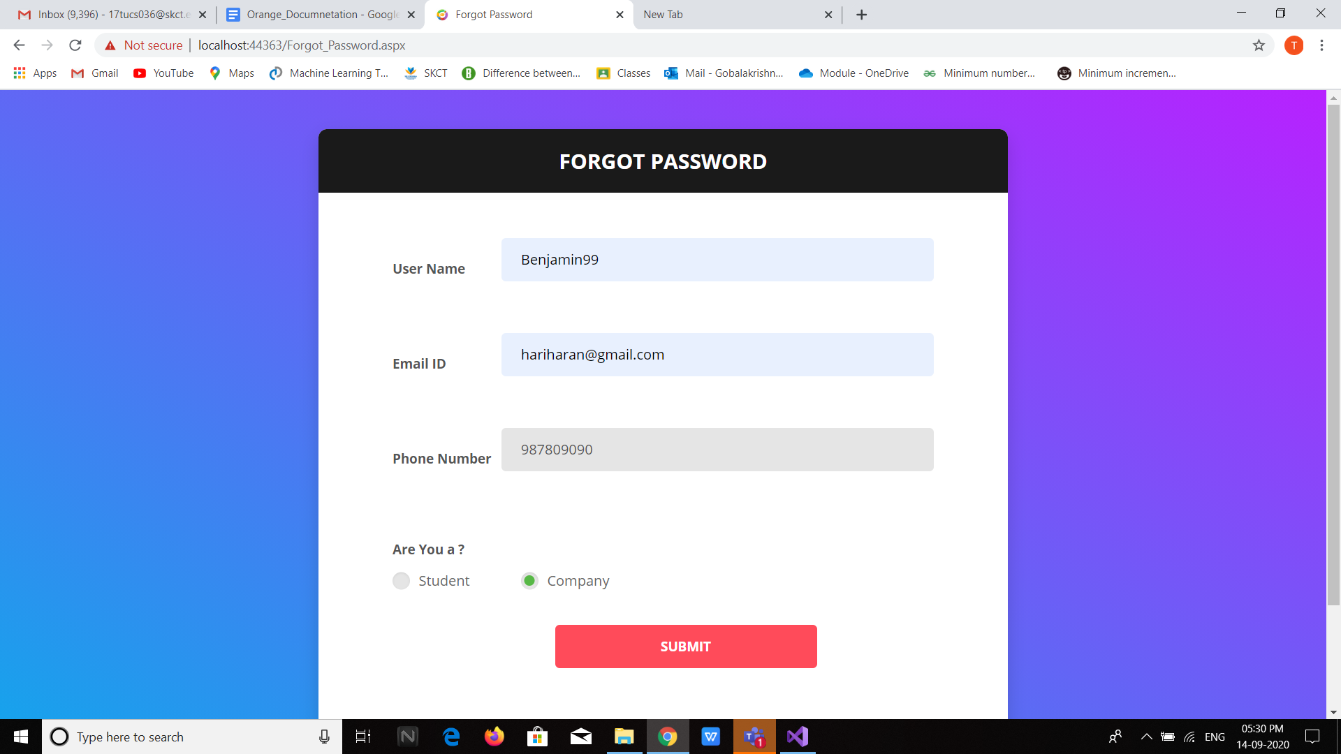

**ROLES AND RESPONSIBILITIES**

**SCREENSHOT WISE:**

|  |  |  |  |
| --- | --- | --- | --- |
| **Screenshot No** | **Page Name** | **Frontend** | **Backend** |
| 1 | Login Page | Kuttralanathan | Kuttralanathan |
| 2 | Common Signup | Kuttralanathan | Kuttralanathan |
| 2.1 | Student Signup | Rajagurunathan | Akash |
| 2.2 | Company Signup | Gobalakrishnasridhar | Hariharan |
| 3 | Student Dashboard | Akash | Rajagurunathan |
| 4 | Applied Job | Rajagurunathan | Akash |
| 5 | Student Inbox | Kuttralanathan | Akash |
| 6.1 | Student - Edit Profile | Akash | Rajagurunathan |
| 6.2 | Student - Update Profile | Rajagurunathan | Akash |
| 7 | Company Dashboard | Gobalakrishnasridhar | Hariharan |
| 8 | Add Job | Hariharan | Gobalakrishnasridhar |
| 9 | Company Inbox | Hariharan | Gobalakrishnasridhar |
| 10.1 | Company - Edit Profile | Hariharan | Gobalakrishnasridhar |
| 10.2 | Company - Change Password | Gobalakrishnasridhar | Hariharan |
| 11 | Forgot Password | Rajagurunathan | Kuttralanathan |

**MODULE WISE:**

**1) Member Name: Akash S**

* Database Online Hosting
* Student Signup - Back End
* Student Dashboard - Front End
* Student Inbox - Back End
* Student Profile - Front End
* Student Education Details - Back End
* Data Validation

**2) Member Name: Gobalakrishnasridhar T**

* Company Registration - Frontend
* DB Schema
* Company Home - Frontend
* Company AddJob - Backend
* Company Inbox- Backend
* Company Profile- Frontend and Backend
* Dry Run
* Company side - Query Management

**3) Member Name: Hariharan T**

* Company Registration - Backend
* DB Schema
* Company Home - Backend
* Company AddJob - Frontend
* Company Inbox- Frontend
* Company Profile- Frontend and Backend
* Logo and background image design

**4) Member Name: Kuttralanathan K**

* Login Page - Front End and Back End
* Forgot Password Page - Back End
* Common SignUp - Front End and Back End
* Student Inbox - Front End
* Login/Logout Session Management
* Project Layout Design Architect
* Dry Run
* Overall Integration

**5) Member Name: Rajagurunathan M**

* Forgot Password - Front End
* Student Signup - Front End
* Student Dashboard - Back End
* Student Profile - Back End
* Student Education Details - Front End
* Student side - Query Management

**PROJECT SOURCE CODE LINK**

**Onedrive:**

[**https://kovailtd-my.sharepoint.com/personal/syed_haroon_kovai_co/_layouts/15/onedrive.aspx?originalPath=aHR0cHM6Ly9rb3ZhaWx0ZC1teS5zaGFyZXBvaW50LmNvbS86ZjovZy9wZXJzb25hbC9zeWVkX2hhcm9vbl9rb3ZhaV9jby9FdF9sNjM2VVN1Tk1wZHI1dWFOTk9fSUJuY1lqdDRfN2liVThlYjQ3cXcxNHlnP3J0aW1lPWc4QXIwVXcxMkVn&id=%2Fpersonal%2Fsyed%5Fharoon%5Fkovai%5Fco%2FDocuments%2FIntern%2FModule%2FAsp%2ENet%5FMiniProject%5FSourceCode%2FOnline%20Campus%20Selection%20System**](https://kovailtd-my.sharepoint.com/personal/syed_haroon_kovai_co/_layouts/15/onedrive.aspx?originalPath=aHR0cHM6Ly9rb3ZhaWx0ZC1teS5zaGFyZXBvaW50LmNvbS86ZjovZy9wZXJzb25hbC9zeWVkX2hhcm9vbl9rb3ZhaV9jby9FdF9sNjM2VVN1Tk1wZHI1dWFOTk9fSUJuY1lqdDRfN2liVThlYjQ3cXcxNHlnP3J0aW1lPWc4QXIwVXcxMkVn&id=%2Fpersonal%2Fsyed%5Fharoon%5Fkovai%5Fco%2FDocuments%2FIntern%2FModule%2FAsp%2ENet%5FMiniProject%5FSourceCode%2FOnline%20Campus%20Selection%20System)